WILTON PRESBYTERIAN AND ST. MATTHEWS HIGH SCHOOL JOINT YOUTH 2018-2019
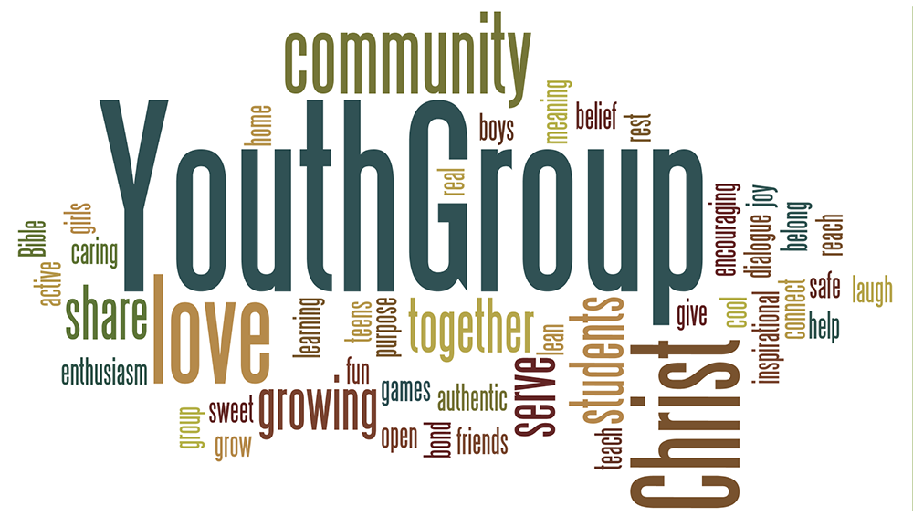
All Lunch Gatherings filled with food and fellowship will be 11:30-1pm in the lower core.
Friends are welcome!!!
September January
Sunday, September 16- Welcome back Luncheon Sunday, January 6- Field trip Colony Pizza
Wednesday, September 19 (Yom Kippur) Sunday, January 27- Study Break Gathering
NYC (Tenement Museum, Lombardi’s Pizza)
October February
Sunday, October 14- Lunch Gathering Sunday, February 3- D.C. Orientation Meeting*
Saturday, October 20- Rise Against Hunger!! Wednesday, February 13-18- D.C. Mission Trip*
Sunday, October 28- Lunch Gathering
November March
Sunday, November 6- Rake and Roll Sunday, March 3- Lunch Gathering
Sunday, November 18- D.C. Mission trip Info Mtg.* Sunday, March 24-Lunch Gathering
December April
Sunday, December 2- Christmas Party Sunday, April 7- HS End of Year Party
Saturday, December 8- Bake Sale for D.C.* May
Sunday, May 5- HS BONFIRE
*High School DC Mission Trip February 13-18th
A hands-on opportunity to work in soup kitchens and homeless shelters in the Washington DC area. High School students currently active in one of our Churches are invited to apply. High School applicants must attend both the November 18th info session and the February 3th orientation session as well as work on the fundraisers to help defray program costs. If you are in High School and may want to apply, be sure to continue to be an active participant in your Church, Joint Youth Group and attend the November 18th information session to become eligible to apply.
Sunday, November 18th, 11:30 am Mandatory session for potential HS applicants(parents welcome.)
Saturday, December 8, 10am-2pm Mandatory Fundraiser at Various School Locations
Saturday, December 8 Application Deadline
Sunday, February 3, 11:30am Mandatory Orientation for all HS Team Members
January-March Mandatory Citrus Sale Fundraiser
Wednesday, February 13 8am- Luggage drop-off at WEPCO
3:10pm- Group departure for DC
Monday, February 18 3pm- Arrive back in Wilton
Questions?
Julie Fowler, WPC Julie.fowler@wiltonpresbyterian.org 917-446-3510 Becky Hudspeth, St. Matthews beckyhuds@gmail.com 203-246-8407

