**Announcements**



1. Log on to smile.amazon.com

2. Sign –in as a Member **or** Click “Get Started.”  Then, enter the requested information.

3. You will be given the opportunity to select a charity.

Please search: **First Toms River United Methodist Church**

August 8, 2021

**First United Methodist Church of Toms River**

129 Chestnut Street

At Old Freehold Road

Toms River, NJ 08753

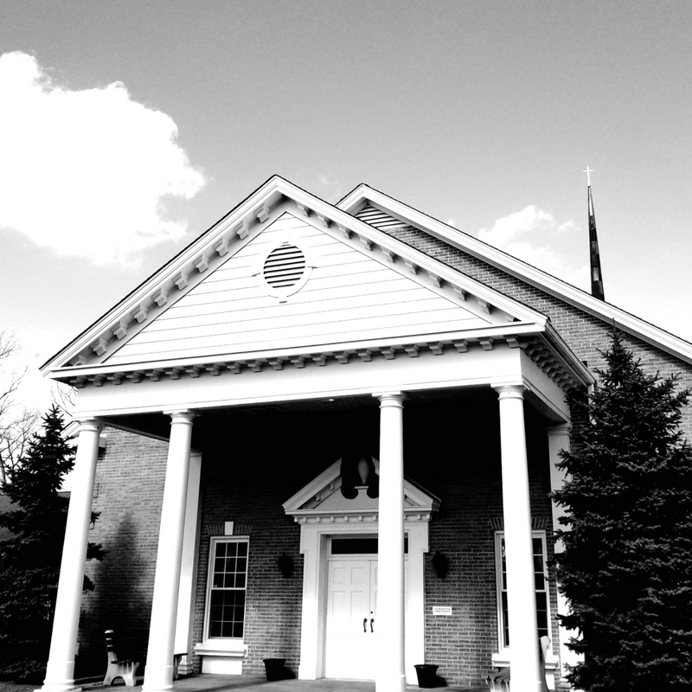

Christ Centered- Spirit Led

***Our Mission***

*Belonging to the Family*

*Believing the Good News*

*Becoming like Jesus*

*Our website*

[***www.fumctr.com***](http://www.fumctr.com)





*Shoprite cards* are available to purchase after 9am and before 10:30 worship on the **2nd & 4th** Sundays. A percentage of all cards purchased is given to First Church

Total given for the ministry of our church on August 1st was: **$6603.00**

And the current Family Life Center balance forthis month is $**498,056.75**

**First Time Guest?** *Stop by the visitors table to get some information and complete a “welcome form”. So nice to have you join our First Church Family today!*





**(October 1 & 2)**

Rummage Sale Donations …

start collecting…

**Clothing, kitchen items, electrical items, holiday items, housewares, small appliances, linens, bedding, glassware, picture frames, toys, games, books, CD’s, movies, knick- knacks and jewelry.  You may begin to drop off your items after 11:00 am on Sunday, September 26th. The last day to receive donations will be Thursday, September 30th.**

***All books, CD’s, movies and jewelry donations will be sold at the Holly Berry Bazaar.***

**This is your opportunity to clean house and get rid of unwanted items.  We will not accept large pieces of furniture, worn or torn items, TVs, or damaged goods.**

**No exceptions!**

***Thank you all for your donations!***

[**www.fumctr.com/donate**](http://www.fumctr.com/donate)

**You can subscribe for monthly or**

**Weekly giving**



**The Church with the Lighted Steeple**

**and the Friendly People**

Ed Davis, ***Senior Pastor......................................****. ed@fumctr.com*

Wes Ellis, ***Associate Pastor…………….………...****wesellis@fumctr.com*

Brian Krajcik, ***Worship Director……...................****brian@fumctr.com*

Bob Ferrara, ***Lay Leader…………………………..…****Office@fumctr.com*

Paula Smith, ***Administrator…………………………****Office@fumctr.com*

Church Office: 732-349-8155 fax: 732-244-0524

**Church Office Hours: Monday-Friday, 9:00am – 12:30**



Ken Zier, 11

Ed Davis, 11

John Devoe, 11

Jill Metzler, 13

Dinean Batchelder, 14



***Thank you to everyone who participated in this ministry. Our grounds look wonderful!! Keep up the great work.***





**Flowers on the Communion table in the Sanctuary are given to the glory of God**

**Our Third Quarter Mission Giving**

**Is for *Educational Assistance Gifts***



**FLC:** Family Life Center, **TH:** Thompson Hall,  **R4**: Room 4, **R5-6**: Room 5 & 6, **S:** Sanctuary, **CR**: Choir Room

**WR**: Whilden Room, **RR:** Reeve’s Room

**SUNDAY, 8.8**

9:00 Family Life Center Worship

10:30 Sanctuary Worship

Food Collection & Shoprite Cards

**MONDAY, 8.9**

7:00 Ruth Circle, TH

**TUESDAY, 8.10**

10-12 Knitters, TH

7:15 Praise Team, FLC

**THURSDAY, 8.12**

10:00 Facebook Online devotional with Pastor Wes

also on [www.fumctr.com](http://www.fumctr.com)

**FRIDAY, 8.13**

6:00 College Group, TH

**SATURDAY, 8.14**

11:00 Funeral (Sanctuary) for Diane Latshaw, followed by repast in the Family Life Center

**FLC**: Family Life Center, **TH**: Thompson Hall, **RR**: Reeves Room, **CR**: Choir Room

**R4**: Room 4, **R5-6** Room 5 & 6 **S**: Sanctuary



The Hope Center with whom we partner, is looking for a ***Client Services Assistant***. Responsibilities for this paid position would include working with volunteers and staff members to fulfill the organizational mission of the Hope Center and promoting Hope Center services within the community. The position is two days a week from 9am – 3pm. If you are interested in finding out more about this great opportunity, contact Amy VanBezooijen at 732-341-4447 or email avanbezooijen@houseofhopeocean.org





**Happy Anniversary**

**Manny & Betty Lou Pinto, 13**

Online Weekly with

Pastor Wes

On Facebook or [www.fumctr.com/devotional](http://www.fumctr.com/devotional)

Thursday 10:00am

Holly Berry Bazaar

November 6, 2021





***Continued prayers for:***

Dan Clinch, Daniel Capuano, George & Adrianne Melnyk, Evelyn Paulsen, Liz Mitchell, Barbara Dawson,

Randy, Paula & Joshua Smith