Thinking about Christmas shopping?
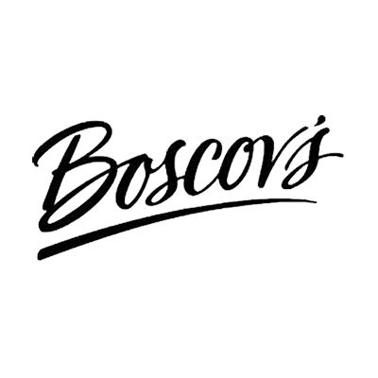
Here are a few ways to help First Church while you are finding that perfect holiday gift!

♦ Do you like shopping at ?

On Wednesday, October 20th, Boscov’s is holding its Friends Helping Friends sale.
For a $5 donation to First Church, you get a 25% off discount shopping pass which is
good at every Boscov’s store from 8 AM to 11 PM on October 20th.

Shopping passes will be available after the 9AM service and before the 10:30 service on
October 10 and October 17. We will also have a table at the North Door of the Boscov’s
store in the Ocean County Mall from 3 PM to 6 PM on October 20th.

If you are interested in purchasing a shopping pass OR if you are interested in helping
with this program, contact Kim at kgeneral83@gmail.com.

100% of every donation will go directly to the ministries of First Church.

♦ Are you looking for amazing hand-crafted gifts?

Be sure to put the Holly Berry Bazaar on your calendar! From 9AM to 4PM on
Saturday, November 6th, the United Methodist Women will be holding their annual
holiday craft fair in the Family Life Center.

Quilts, ornaments, hats, scarves, baked goods, books and jewelry are just
some of the treasures that will be available for purchase. This event is
guaranteed to put you in the holiday spirit! Come and bring your friends!

♦ Do you shop on-line?

You can support First Toms River United Methodist Church when
you shop at smile.amazon.com

1. Start at smile.amazon.com
2. Choose First Toms River United Methodist Church
as your charity.
3. Amazon will donate a portion of your eligible purchases
to our church at no cost to you.

Thank you so much for your support! Happy Shopping!

