PARKING LOT WORSHIP PLAN
*All worship plans were made to adhere to social distancing guidelines as directed by Governor Abbott and the Pearland City Government and to keep all members, guests and staff healthy and safe. Please wear your masks.
Location: New Life Lutheran Church, Parking Lot
Parking Lot Opens at 7:30 a.m. The orange cones designate no-parking.
Worship Begins 8:00 a.m., promptly, and is expected to last about 45 minutes.
Worship will be Livestreamed.
Worship from Your Parking Space as members in the same household or family. Please arrive in the same vehicle due to limited parking and social distancing. Car occupants should remain together and within 5 feet of the front and back of your vehicle. Tailgating is encouraged; however, visiting other vehicles is not.
Please Submit Only One RSVP per Family Vehicle through the Facebook Event OR call/text Tiffany in the Church office by End of Day Thursday. Should we need more space, we may need to reorient the parking spaces.
BEFORE WORSHIP
Park and Turn Off Your Engine so others do not breathe exhaust.
Arrive Early to Setup your space, if sitting outside your vehicle. Sit in front. Do not move cones, Do not sit or set up between or beside vehicles, and always follow 6-foot social distancing expectations.
Print Bulletins at Home, if you can to decrease the risk of surface contact spread. Bulletins will be available for those who forget.
Each Vehicle Occupant Should Complete the Health Self-Screening Assessment the morning prior to departing your home. If you answer yes to any of the questions below, please do not attend parking lot worship this day, contact your doctor, and let our care team know.
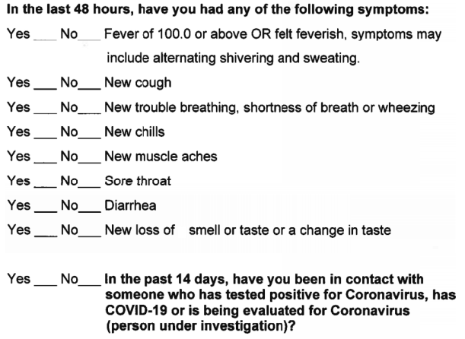
DURING WORSHIP
Remain at Your Space the duration of worship. You are responsible for safely social distancing. Bring masks or gloves to wear as needed.
As Passing of the Peace is declared, pass peace within your space and wave your peace to those nearby; do not visit between vehicles or approach staff. A staff member may walk around with the livestream feed for you to pass peace and greet to those worshiping online.
After Worship, you may remain in your space for distancing fellowship, if desired. When departing, please safely exit the parking lot.
In The Event of Rainout, you may still sit in the parking lot and stream from your phone in your car.
Building access will be restricted and occupancy will be limited to emergency bathroom needs of elderly or small children; masks or face coverings are required inside buildings. In this situation, accompany any minor child. If you must enter a building, you are required to disinfect all touched surfaces. Please bring your own disinfectant at this time.
PLEASE HAVE PATIENCE DURING THIS PROCESS AS WE WORK TO ENSURE THE HEALTH AND SAFETY OF ALL.

