Community News
Welcome to worship at Wake Forest Baptist Church. We are a welcoming and affirming congregation, welcoming all people, no matter your race, economic status, gender expression, or sexual orientation into full membership and leadership. If you are a visitor, please take a moment to fill out a visitor card with your name and contact information and tell us how you’re doing.

Today is the first Sunday of month. We will share communion together and welcome your hunger offering—whether as a food offering for Samaritan Ministries or a cash or designated check offering for a local organization fighting hunger.

Preaching today is Erica Saunders, a second year Divinity student from Wake Forest University. Her many gifts and talents, include her interest in the New Testament (especially in the original Greek.) Erica, thank you for your willing spirit and wise words.

Our new office phone number is 336-860-0777.

Pastor Lia’s email address is Pastor@wakeforestbaptist.org, and Christie Dalton, Minister of Congregational Development’s email is MinisterofCD@wakeforestbaptist.org.

Music and lyrics are reprinted with permission of OneLicense #A-719218.

Calendar of Activities

Sunday, June 10 Fourth Sunday of Season after Pentecost
9:45 Sunday School Classes
11:00 Worship in Davis Chapel and Beans! Beans! Offering

Sunday, June 17 Fifth Sunday of Season after Pentecost
9:45 Sunday School Classes
11:00 Worship in Davis Chapel
2:00 Administrative Council, Balcony Room

Wake Forest Baptist Church is a progressive, welcoming and affirming
Christian community committed to Jesus Christ. We value prophetic worship, thoughtful religious education, social justice, and peacemaking.

Pastor Phone: 336-414-3640 Church Office Phone: 336-860-0777
P.O. Box 7326, Winston-Salem, North Carolina 27109-7326
www.wakeforestbaptist.org

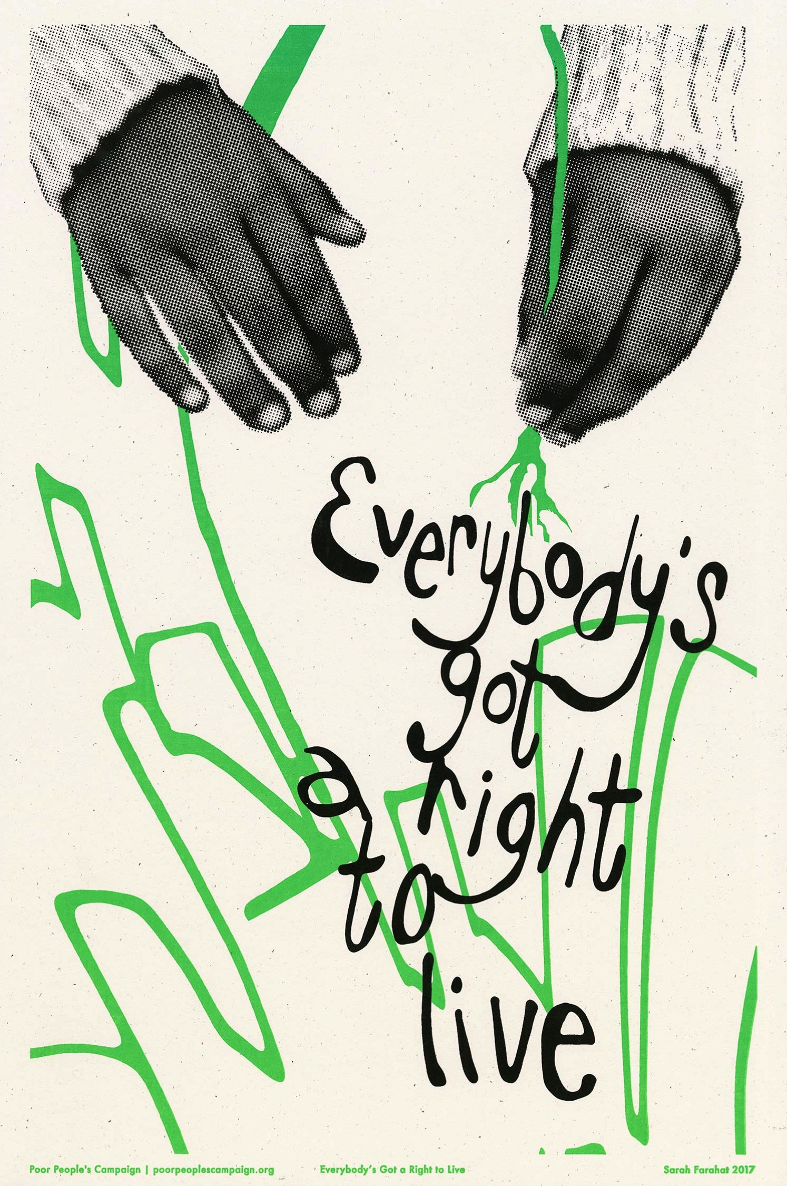

Wake Forest Baptist Church
June 3, 2018
Wake Forest Baptist Church
Third Sunday of Season after Pentecost

Gathering
Preparation for Worship

Prelude Morning Has Broken Kelly Hammond
Arr. Fred Bock

* Call to Worship (in unison) Charley Bratton
Who put the copper into beech trees and the waddle into penguins?
Who chose the colors of rainbows and put shapes into clouds?
The Spirit of creation, God’s imagination.

Who put the notes into music and picked the dance steps for bees?
Who placed the hum in hummingbirds and made elephants listen with their feet?
The Spirit of creation, God’s imagination.

Who invented yeast to make bread rise and put the curve into bananas?
Who made laughter infectious and chocolate taste like heaven?
The Spirit of creation, God’s imagination.

* Hymn of Praise #452 Here I Am, Lord Here I Am, Lord

* Opening Prayer Alexx Andersen

Sharing
* Passing the Peace of Christ

* Gathering Hymn Make Us One Make Us One
Make us one, Lord, make us one.
Holy Spirit, make us one.
Let your love flow so the world will know,
we are one in you.

Prayers of the People Erica Saunders

* Offering Hymn #453 Called as Partners in Christ’s Service Beecher

Offertory Blessed Assurance
Phoebe P. Knapp, Arr. Jan Sanborn

* Giving Our Tithes and Offerings Lasst Uns Erfreuen
Praise God, from whom all blessings flow.
Praise God, all creatures high and low.
Alleluia! Alleluia!
Praise God, in Jesus fully known:
Creator, Word, and Spirit one.
Alleluia! Alleluia! Alleluia! Alleluia! Alleluia!

* Offertory Prayer

Proclaiming
Lesson from the Epistles 1 Peter 2:18-25, 3:1-6

Reader: This is the Word of the Lord. All: Thanks be to God.

Anthem #454 Come, Celebrate the Call of God Alida’s Tune

Sermon Imagine Erica Saunders

Responding
Communion
Please remain seated during Communion. The elements (bread and juice) will be passed to you. As you receive the bread, dip it in the cup. All are welcome, no exceptions.

* Communion Hymn #284 Gather Us In Beach Spring

We invite you to commit your life to Christ as a disciple and to join our church
as a member. You may also wish to reaffirm your faith in Christ or make other commitments.
You are welcome to come forward at this time.

Announcements and Welcoming New Members

* Sung Benediction #614 I’m Gonna Live So God Can Use Me I’m Gonna Live

* Benediction

