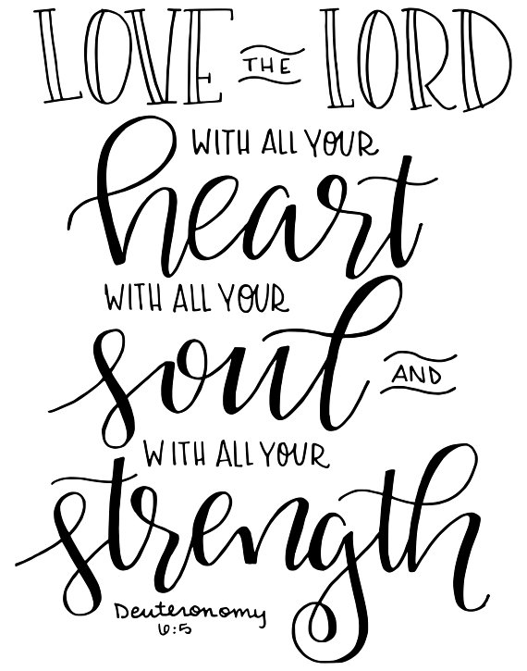
Welcome to worship at Wake Forest Baptist Church, where all are welcome, no exceptions. Bienvenidos a Iglesia Bautista Wake Forest donde todos y todas son bienvenidos sin excepciones. We are a welcoming and affirming congregation, welcoming all people, no matter their race, economic status, gender expression, or sexual orientation into full membership and leadership. If you are a visitor, please take a moment to sign our guest book.

Welcome to our guest preacher, Reverend Demi McCoy, who is the Assistant Director of Public Religious Leadership and Community Engagement at the WFU School of Divinity. Demi is an up and coming hip-hop musician, a spoken word artist, and incredible preacher.

Also, welcome to our student Leah Bonsall, harpist, and Gwen Gregory, our guest pianist.

This morning we will receive your hunger offering. Next Sunday we will receive your Beans! Beans! Offering. (Please bring one pound bags of beans, nothing larger.)
Following worship, join us for a time of fun and fellowship at a Potluck Lunch in the Lower Auditorium. Students, you don’t need to bring a dish; you’re our special guests.
Saturday, October 19 - Dance, skip, and march with us in the PRIDE parade. Meet us in front of Foothills Brewery downtown at 10:00 a.m. Look for our white truck with the unicorn on top. Silly hats and outlandish costumes are welcome! Next Sunday we’ll have a sign up sheet.

Music and lyrics are reprinted with permission of OneLicense #A-719218. The Call to Worship was written by Reverend Mandy England Cole.

Wake Forest Baptist Church is a progressive, welcoming and affirming Christian community committed to Jesus Christ. We value prophetic worship, thoughtful religious education, social justice, and peacemaking.

Pastor’s Phone: 336-414-3640 P.O. Box 7326
wakeforestbaptist.org Winston-Salem, NC 27109

Seventeenth Sunday after
Pentecost

October 6, 2019

Prelude Leah Bonsall

Welcome and Opening Words Sara Sinal

* Call to Worship (bold in unison)
God of us—of the assembly gathered here,
living in this place, in this time.
God of us—Here. Alive. Today.
You are our God—the One,
who makes covenant with, promises to, requests of.
As we worship, write your words anew on our hearts—
that our lives may be a testimony to the covenant we keep,
embodying you in all we are and in all we do.
Let us worship together!

* Hymn Sing
#618 How Firm a Foundation Foundation
#86 Great is Thy Faithfulness Faithfulness

* Opening Prayer Alexx Andersen

* Sharing the Peace of Christ St. Denio
From Wisdom emerging, we fashion a space
for people converging in safety and grace,
to shelter the freedom of one and of all
in Love without border or boundary or wall.

Prayer
Our Father, who art in heaven, hallowed be thy name, thy kingdom come, thy will be done, on earth as it is in heaven. Give us this day our daily bread. And forgive us our trespasses, as we forgive those who trespass against us. And lead us not into temptation, but deliver us from evil. For thine is the kingdom, and the power, and the glory, for ever and ever. Amen.

Lesson from Our Sacred Text Deuteronomy 5:1-21; 6:4-9

Anthem Leah Bonsall

Sermon What’s on Your Heart? Demi McCoy

* Music O Worship the King Lyons
O worship the King all glorious above,
and gratefully sing God's wonderful love,
our Shield and Defender, the Ancient of Days,
pavilioned in splendor and girded with praise.

Your bountiful care what tongue can recite?
It breathes in the air, it shines in the light;
it streams from the hills, it descends to the plain,
and sweetly distills in the dew and the rain.

Frail children of dust, and feeble as frail,
in you do we trust, nor find you to fail;
your mercies how tender, how firm to the end,
our Maker, Defender, Redeemer, and Friend!

Sharing Our Gifts Leah Bonsall

* Presenting Our Gifts Lasst Uns Erfreuen
Praise God from Whom All Blessings Come
From all that dwell below the skies
let the Creator’s praise arise:
Alleluia! Alleluia!

Let the Redeemer’s name be sung
through every land, in every tongue.
Alleluia! Alleluia! Alleluia! Alleluia! Alleluia!

* Prayer of Gratitude and Celebration

Announcements Eve Andrews

* Closing Music Lord, Dismiss Us with Your Blessing Sicilian Mariners
Lord, dismiss us with your blessing;
fill our hearts with joy and peace.
Let us each, your love possessing,
triumph in redeeming grace.
Oh, direct us and protect us,
traveling through this wilderness.

Thanks we give and adoration
for your gospel’s joyful sound.
May the fruits of your salvation
in our hearts and lives abound.
Ever faithful, ever faithful
to your truth may we be found.
Attributed to John Fawcett, 1773

* Sending Out

Postlude Gwen Gregory

