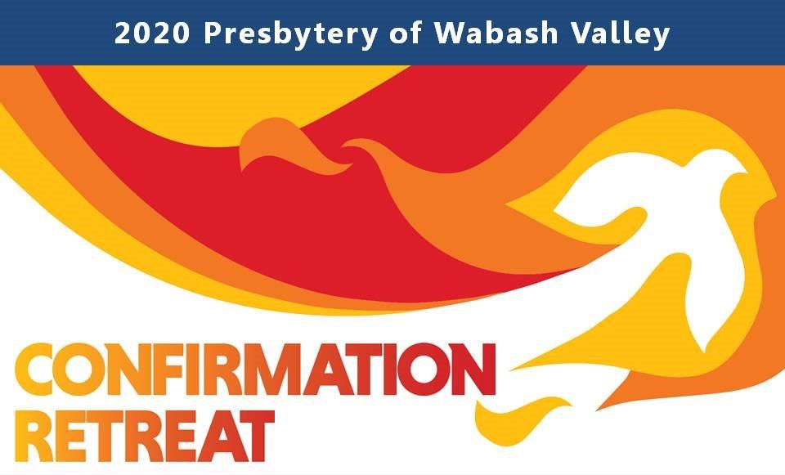
2020 Confirmation Retreat
Registration/Covenant Form

Due: January 13, 2020
If you registered online please print and complete this document and bring with you on January 31 and give to the registrar.

Name: __________________________________ __ ___
Age: ______ Grade: _____ Gender (for Room Assignment): ______

Address: _ _____________________________________________

Church & City: _ ___________

Parent Name: _ ____________________________

Emergency Contact: ____________________________________________ Phone: ______________________

Allergies: ____________________________________________________________________________________

Medications: _________________________________________________________________________________

Special Dietary Needs: __________________________________________________________________________

Please return by January 13, 2020 the completed registration information and the fees due to:
($125.00 for the retreat with a $75.00 deposit per registration with checks payable to Presbytery of Wabash Valley)
Mail to: Presbytery of Wabash Valley • PO Box 225 • Rochester IN 46975-7382
…………………………………………………………………………………………………..

A Confirmation Covenant
We are a community of people learning who we will be. On our Confirmation Retreat, we know that this work is important and, at times, will be challenging. So that we can all work together in this time of learning and play, we agree to be guided by these rules in our confirmation community:
- We will be honest; we will share our thoughts, hopes, and expectations with one another.
- We will be fully engaged. When we come to the Confirmation Retreat, we will do our best to make sure that, for the weekend we have together, we are paying attention to one another and the topics we’re discussing.
- We will pray for ourselves, and for one another.
- We will respect one another’s privacy. What we share in Confirmation is confidential.
- We will respect everyone; fellow students, teachers, and others involved in the class.
- We will be as on time as possible to every activity.
- We will not bully, tease, or prank anyone, at any time.
- We will do our best to make sure EVERYONE is involved or included in what we’re doing.
- We will not be violent with our words or our bodies, either to ourselves or one another.
- We will hold one another accountable to the covenant we’ve created.

Our signatures are just one of many ways we will help one another stay faithful to this covenant. By signing together, we make these promises not just to the other people in our class, but to ourselves and to God.

__________________________________________ ___________________________________________ __________
Student Parent/Guardian Date

