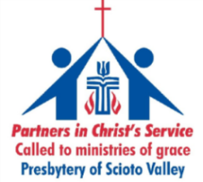
The Presbytery of Scioto Valley 2019 Mission Work Trip
Presbytery-wide Cooperative Mission Trip for Adults
in partnership with the Presbyterian Disaster Assistance (PDA)
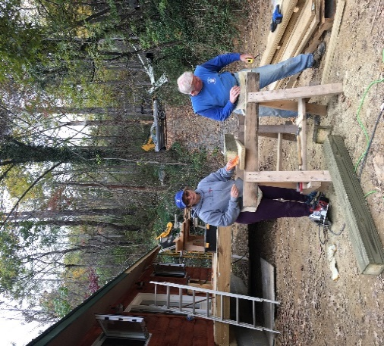
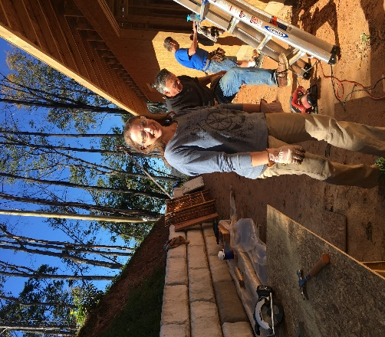
October 27 – November 2, 2019
Purpose: To work with PDA and partners in reconstruction and rebuilding from Hurricane Florence in 2018.
Where: Wilmington Presbyterian Church, Wilmington, NC
Cost: $400 per person, adults 18 & over.

Personal Information
Name________________________________________________ Date of Birth _______________
Address ________________________________________________________________________
_________________________________________________________________________
Phone: _____________________________ Cell phone: __________________________________
E-mail address: _____________________________________________ T-shirt Size: ________
Church: _______________________________________________________________________
Emergency contact information
Name ______________________________________ Relationship ___________________________
Cell Phone: __________________________ Email: ________________________________________
SKILLS INFORMATION: What is your usual occupation? ______________________________. Lead work crew? Yes___ No ___.
Please indicate on this form your approximate level of skill using #1-5 to grade experience as listed below:
#1 __ haven’t done, but willing to try. # 2___ have done but need guidance. #3 ___ can do well independently.
#4___ can do well and guide others. # 5___working in trade.
Debris Removal ___ Heaving Lifting ___ Foundation ___ Tear out drywall, floors ___ Framing Carpentry ____ Finishing Carpentry ___ Electrical____ Pluming ___ HVAC ___ Insulation ___ Drywall Hanging ___ Drywall Finishing ___ Siding ___ Window Installation ___ Door Installation ___ Cabinet Installation ___ Flooring: vinyl ___ Tile: ceramic, etc.___ Mason: brick/plaster ___ Priming/Painting ___ Roofing ___ Landscaping ___ Cook ___ Pastor ___ First Aid/CPR Skills ___
Questions: Please contact Jeannie Harsh by E-mail: jeannie@psvonline.org or 614-562-1775. Please return the completed application form and payment of $400 by July 30 to: The Presbytery of Scioto Valley, 4131 N. High Street, Suite B, Columbus, OH 43214-3001. Web site: www.psvonline.org

