Maundy Thursday
April 9, 2020
Worldwide Pandemic
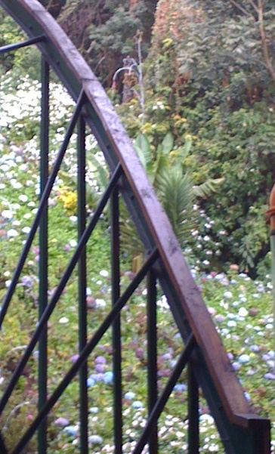
Lexington, KY, USA
Karen Hartsfield
We slide into Holy Week through personal reflection, especially on Maundy Thursday. Upon what are we reflecting? Four instances recorded in the Bible -- two of which were translated from the original Hebrew language and two from the Greek language.
First, Exodus 12:1-14. The LORD said to Moses and Aaron in the land of Egypt: This month shall mark for you the beginning of months; it shall be the first month of the year for you. Tell the whole congregation of Israel that on the tenth of this month they are to take a lamb for each family, a lamb for each household. If a household is too small for a whole lamb, it shall join its closest neighbor in obtaining one; the lamb shall be divided in proportion to the number of people who eat of it. Your lamb shall be without blemish, a year-old male; you may take it from the sheep or from the goats. You shall keep it until the fourteenth day of this month; then the whole assembled congregation of Israel shall slaughter it at twilight. They shall take some of the blood and put it on the two doorposts and the lintel of the houses in which they eat it. They shall eat the lamb that same night; they shall eat it roasted over the fire with unleavened bread and bitter herbs. Do not eat any of it raw or boiled in water, but roasted over the fire, with its head, legs, and inner organs. You shall let none of it remain until the morning; anything that remains until the morning you shall burn. This is how you shall eat it: your loins girded, your sandals on your feet, and your staff in your hand; and you shall eat it hurriedly. It is the passover of the LORD. For I will pass through the land of Egypt that night, and I will strike down every firstborn in the land of Egypt, both human beings and animals; on all the gods of Egypt I will execute judgments: I am the LORD. The blood shall be a sign for you on the houses where you live: when I see the blood, I will pass over you, and no plague shall destroy you when I strike the land of Egypt. This day shall be a day of remembrance for you. You shall celebrate it as a festival to the LORD; throughout your generations you shall observe it as a perpetual ordinance.
Passover worship began among the Hebrew people thousands of years before the first-century events of Holy Week. When God viewed evidence on doorposts that faithful people had heard and heeded God’s warning, fatal judgment was deferred. “I will pass over you,” God said. “…No plague shall destroy you….” Notice, if you will, the specificity of God’s instructions. Take a lamb “without blemish” to prepare and roast for the meal. Eat unleavened bread and bitter herbs with the lamb. Eat hurriedly, dressed to flee.
Why must they flee? Individuals who believed themselves to be gods threatened survival of those with faith. Hebrew people struggled with Egypt’s Pharaoh, foreshadowing what would happen later between Rome’s military and people of faith they conquered. Worship was expected for whomever held the biggest stick. Worshippers refused. Many were slaughtered.
And so, we come to Jesus. As his mother Mary’s firstborn son, he had participated in Passover services all of his life. As a rabbi, surrounded by fellow believers, he led at least one. Then, from my perspective, during Holy Week, he became the Passover sacrifice itself – the Lamb without blemish.
Second scriptural guide today is Psalm 116: 1-2, 12-19. I love the LORD, because he has heard my voice and my supplications. Because he inclined his ear to me, therefore I will call on him as long as I live. What shall I return to the LORD for all his bounty to me? I will lift up the cup of salvation and call on the name of the LORD, I will pay my vows to the LORD in the presence of all his people. Precious in the sight of the LORD is the death of his faithful ones. O LORD, I am your servant; I am your servant, the child of your serving girl. You have loosed my bonds. I will offer to you a thanksgiving sacrifice and call on the name of the LORD. I will pay my vows to the LORD in the presence of all his people, in the courts of the house of the LORD, in your midst, O Jerusalem. Praise the LORD!
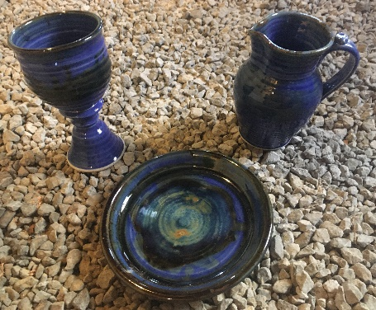
During the Passover service, a cup of blessing, or salvation, is raised. Worship itself is called a sacrifice of thanksgiving. Worshippers vow to serve the LORD unto death, because God has “loosed” our “bonds” – our lifelong fear of dying. With God, life – however different it may be – does not cease. And, for that, worshippers express whole-hearted gratitude.
Third verbal guide is 1 Corinthians 11:23-26. For I received from the Lord what I also handed on to you, that the Lord Jesus on the night when he was betrayed took a loaf of bread, and when he had given thanks, he broke it and said, “This is my body that is for you. Do this in remembrance of me.” In the same way he took the cup also, after supper, saying, “This cup is the new covenant in my blood. Do this, as often as you drink it, in remembrance of me.” For as often as you eat this bread and drink the cup, you proclaim the Lord’s death until he comes.
Tonight, worshippers remember Jesus, that he was betrayed after his last meal with disciples. The cup he raised instituted The Lord’s Supper, with its echoes of the Passover service. A new covenant with God emerged, requiring faith that remembers “me” – Jesus, who was born in Nazareth and ministered to whomever would listen.
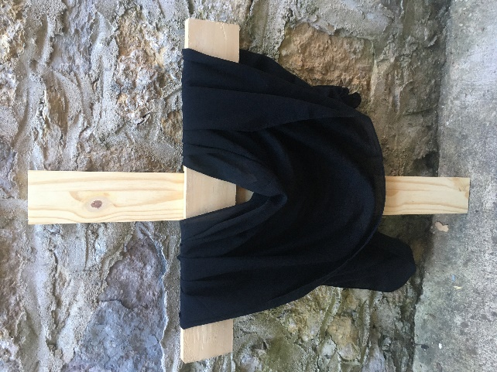
Fourth scripture is John 13:1-17, 31b-35. Now before the festival of the Passover, Jesus knew that his hour had come to depart from this world and go to the Father. Having loved his own who were in the world, he loved them to the end. The devil had already put it into the heart of Judas son of Simon Iscariot to betray him. And during supper Jesus, knowing that the Father had given all things into his hands, and that he had come from God and was going to God, got up from the table, took off his outer robe, and tied a towel around himself. Then he poured water into a basin and began to wash the disciples’ feet and to wipe them with the towel that was tied around him. He came to Simon Peter, who said to him, “Lord, are you going to wash my feet?” Jesus answered, “You do not know now what I am doing, but later you will understand.” Peter said to him, “You will never wash my feet.” Jesus answered, “Unless I wash you, you have no share with me.” Simon Peter said to him, “Lord, not my feet only but also my hands and my head!” Jesus said to him, “One who has bathed does not need to wash, except for the feet, but is entirely clean. And you are clean, though not all of you.” For he knew who was to betray him; for this reason he said, “Not all of you are clean.” After he had washed their feet, had put on his robe, and had returned to the table, he said to them, “Do you know what I have done to you? You call me Teacher and Lord-- and you are right, for that is what I am. So if I, your Lord and Teacher, have washed your feet, you also ought to wash one another’s feet. For I have set you an example, that you also should do as I have done to you. Very truly, I tell you, servants are not greater than their master, nor are messengers greater than the one who sent them. If you know these things, you are blessed if you do them.” When he had gone out, Jesus said, “Now the Son of Man has been glorified, and God has been glorified in him. If God has been glorified in him, God will also glorify him in himself and will glorify him at once. Little children, I am with you only a little longer. You will look for me; and as I said to the Jews so now I say to you, ‘Where I am going, you cannot come.’ I give you a new commandment, that you love one another. Just as I have loved you, you also should love one another. By this everyone will know that you are my disciples, if you have love for one another.”
As we shelter in place from a virulent virus, a “plague” from which it’s difficult to run, we have time to contemplate God’s will for our lives. Jesus set us an example. I’m not referring, at the moment, to his willing self-sacrifice unto death, because he alone could accomplish that task, once, and for the sake of all humankind that will “listen.”
He said, “Wash one another’s feet.” I don’t know about you, but I find that a difficult commandment, interpreted literally. Take into my hands someone else’s “uncleanness?” My own calloused, dirty feet are bad enough!
But, “Love one another.” When I see another person, like myself or not, with a limp or a swagger, I am to “love,” not judge, with God’s help. That’s how “everyone” will know I am God’s daughter – a person of faith.
On Maundy Thursday, worshippers remember how Judas’ judgment of Jesus went so very wrong. Even so, Jesus washed “unclean” Judas’ feet, too. By this, we know the true nature of God’s love.

